**Amphibian facility for Craig Hassapakis.**

**Short guidance.**

1. **Feeder insects cultures.**

1. *Achaeta domestica*

2. *Schelfordella lateralis*

Both species are the best choice for most amphibians except the water phase of salamandridae/ ambystomatidae and other caudated amphibians.

Both species may be kept in the same room as they’re need similar husbandry conditions i.e. average temperature, humidity etc.

Design of the boxes may be used of the same style:

The main requirement is to be escape-proof that in case of both species means the decent height of the boxes no less than 1.3 meters. The other parameters may vary widely from 80 cm to 120 cm depending on size of the room and shelves/ available boxes.

The average room temperature is best to maintain around 85-86 Fahrenheit grades with use of local hot-spot area up to 95 F (on both lateral sides of the box) by using the common lamp bulbs (working day and night).

The watering may be arranged by different ways including daily slight spraying on a top of the egg crates (used as filling material inside boxes – only possible in case if you have a low humidity inside the room) or to use the water bowls/ auto drinker (several constructions are possible).

In case of spaying you need to be sure that egg crates will dry out within 2 hours completely.

*Substratum* to use: small fraction of woods filings – cheap, easy to clean and replace.

***For crickets*.** The most important thing is to avoid average high humidity and box substratum. Provide good ventilation of boxes and low room humidity.

*Feeding*. In general crickets as well as cockroaches need two types of food – dry food which comprises of proteins (1) and moist food to compensate the water loss and provide vitamins/microelements and carbohydrates (2).

1. Use oat flakes and dry gammarus/daphnia (the latter may be replaced with dog/cat food).
2. Use grated carrots/ apples.

Here is the general data for breeding crickets and their biology:

|  |  |  |  |  |
| --- | --- | --- | --- | --- |
|  | **Embryogenesis time,**  **in days** | **Larvae development,**  **in weeks** | **Imago development,**  **in weeks** | **Eggs laid by single female** |
| *Acheta domesticus* | 10 (79-83°F) | 7 | 12-16 | 800 |

The food shall be provided daily and the old moist food shall be replaced, if any.

The other **important** thing is to manage of the cultures to cycling all ages of crickets separately in different boxes. For this you need to have no less than 6 boxes.

It is not that important for roaches as you can keep all ages in same box. You can also do same for them by collecting ootheca and hutch them out separately (but this is not obligatory).

For general culture of crickets - you can use any of the caresheets available on-line:

<https://www.joshsfrogs.com/catalog/blog/2009/01/cricket-care-sheet/>

<http://www.anapsid.org/crickets.html>

<https://cricketcare.org/breeding/>

In Russia but very good info: <https://www.zoofond.ru/cricket/cricket_info/cricket_full>

***For Turkestan roaches***. You can use same type of boxes as it was told but the additional lamp for hot-spot may be used only on one of the sides. Same egg crates will be used also for arranging space inside the boxes.

Unlike crickets which may maintain without regular misting Turkestan roaches need to mist every day on regular basis.

The only problematic issue is to arranging the proper humidity inside the box, allowing ootheca not to dry out, from one side, and do not allow substratum and egg crates to spoil (rot and covered with fungus) which may kill the roaches culture, from other side. Some people do to avoid this collecting the oothecae and incubate it separately on humid substratum. But this process takes much time.

Good ventilation of boxes and slight misting (everything will dry out within couple of hours – you can try it and see how it will work) is also works well in my case.

Food sources and ration for cockroaches is the same as crickets.

You also need to know that if temperature arising over 35-36 С imagoe males of Turkestan cockroaches may fly outside boxes in the room.

For general care sheet for Turkestan roach:

<https://mrpetsupplies.com/pages/red-runner-care-and-info>

<https://scorpionsalive.co.za/Images/Downloads/How%20to%20keep%20and%20breed%20the%20Turkistan%20Cockroach.pdf>

3. Other additional sources: Fruit fly *Drosophila* spp., white wood louse *Trichorhina tomentosa,* springtails.

**II. Amphibian room.**

**Equipment of the terraria.**

**Light to use.**

For many species simple halogen lamps may be used to light the terraria. Some terraria may not be lightening at all (especially if no alive plants plan to be use, and quarantine ones).

Part of the species need to be kept/grown (especially small frogs/toads/salamanders) under the UVB light. UVB light also may be used as a one of the complex measure for preparation for breeding of the adult (it shall be turned off during diapauses period).

Lamps like *ReptiGlo 2*- *ReptiGlo 5* may be used.

**Substratum to use.**

Best to use are:

1. Coconut substratum (not big chips);
2. Oaken leaves (boiled before use).
3. Sphagnum moss (can be used both for quarantine and regular terraria)

Some species may be kept on water (*Hyla* spp.) with wooden branches and alive plants without substratum at all, during the breeding season (for breeding).

Other stuff to use:

* Alive plants with small (for *Mantella*s) leaves or big leaves (for *Hyla*s) depending on the species;
* Wooden branches for regular terrariums;
* Artificial plants (for quarantine terraria) which is simple to disinfect and thus may be used multiple times.

Principal construction of terrarium.

**One of the main requirements for amphibian terrarium is high level of ventilation as absolute most of them afraid of stagnant air. So, good circulation of air inside the terrarium is absolutely necessary. It may need no special technical equipment but just using the proper construction using the principle of natural convection.**

Top part is removable (simply put on terrarium above)

The top of the terrarium is best to arrange as full screen.

Doors are may be removed (up) and/or shift to sides.

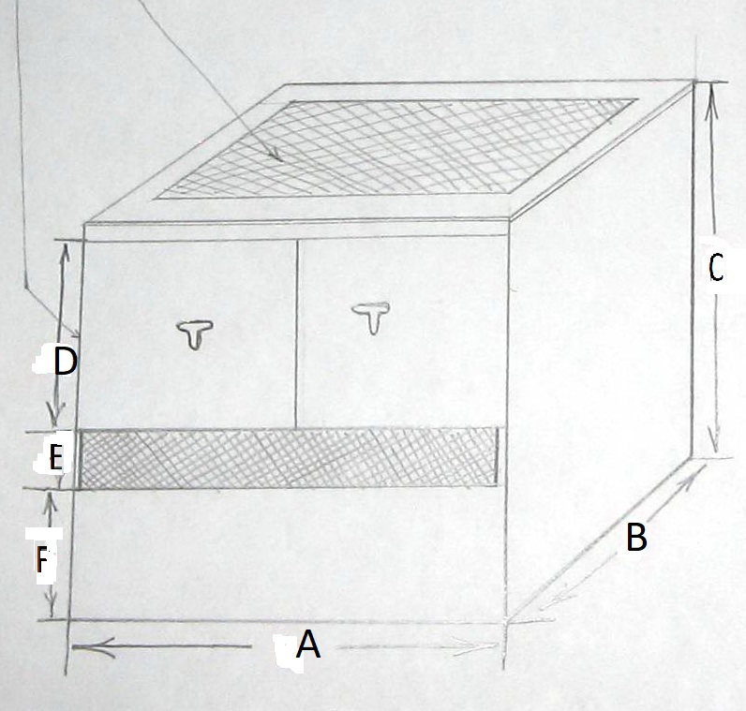

Size of the terrarium (parameters of A-B-C-D-E-F) vary in size depends on the type of the terraria according to the species (vertical, cubic or horizontal) it shall be kept.

Glass can be use of 3 mm (window type glass) as a cheapest one glued by silicon glue. Stainless mesh shall be used for covering the ventilation areas.

Other equipment for the terrarium and suplements:

1. ***Water pump*** to use for “falling water” imitation activity affecting the breeding behaviour (shall works day and night till clutching) which is very important for managing “rainy season” (in my experience may be a key feature to bred “hard” species).
2. “Rainy/misting systems” providing the automatic misting of the terrarium which is important for daily care of many tropical species and which is reduce the time needed to managing care for the animals.
3. Vitamins and microelements supplements for “powdering” the food items.

**Arrangement of quarantine area.**

Quarantine area must be isolated from the main facility (different room). Quarantine may be maintained from 4 weeks to 2 months.

Terraria shall be used of “ascetic style” but shall include:

* Water area, if needed;
* Substratum (pre-sterile) for species in need: most ground caudates and soil and terrestrial/litter amphibians;
* Wooden or artificial branches for tree amphibians;
* Artificial plants to use for tree amphibians.

It is important, while commonly adaptation and acclimatization to artificial conditions happens during the quarantine period, to provide adequate sheltering and disturbances reduce for the wild frogs. In many species is better to cover part to whole terrarium with dark paper or textile material.

The only differences between the quarantine and common conditions are simple terraria equipment (which is providing easy observation of culprits) and precise monitoring of the conditions and behavior of the animals. For example, in case if hiding places are provided they shall be possible to simple remove and manipulate with (like plastic boxes as a hiding places).

**Species included and their specifics:**

1. *Eastern Narrow-mouthed Frog***(*Gastrophryne carolinensis*)**

Is a simple to keep species. The main requirement for this species is a good level of humidity. It is typical burrowing species which needs a big layer substratum of loose soils which shall be kept humid. It also shall be covered with number of leaves above the ground. You can place also several on-ground hiding places.

A small water dish is also good to arrange to be present in the terrarium. You can keep together one male with 2-3 females.

Good source: <http://www.virginiaherpetologicalsociety.com/amphibians/frogsandtoads/eastern-narrow-mouthed-toad/eastern_narrow-mouthed_toad.php>

2. *Northern Slimy Salamander* (***Plethodon glutinosus***) – is quite large species which is highly polymorphic and groups of this species shall be forming within specimens from the same area of habitation as there are closer to 20 species is treated in this complex group (accurate species id may be considering only based on DNA study). It shall be kept separately as forming a natural hybrid forms with species like P. *jordani*, *P. aureoles* and *P. kentucki.*

Typical horizontal terrarium must be arranged as being a terrestrial species for which floor area is more important other than height of the terrarium.

<https://www.caudata.org/cc/species/Plethodon/P_glutinosus.shtml>

3. *Green Tree Frog* (***Hyla cinerea***).

4. *Painted or Baron's mantella***(*Mantella baroni*)** *–* not as other close species painted mantellas afraid of high temperatures and it is the particularity of keeping this species. Another peculiarity is the possibility to feed on larger prey items than other mantellas.

The species is better to keep in larger groups like 5-8. In this species like in most mantellas females may combat during the breeding season in case of a small terrarium provided.

No strong needs for UVB light are needed for this species but to use average (5.0) bulbs is recommended especially during switching after “dry season”.

**As most mantellas it is need good difference/ fluctuation of temperatures between day and night (night loss) and strong control of the average keeping temperature which never allow to raise over 80 F! Normal temperature for *Mantella baroni* is 73-76 F.**

**Also you shall not use UVB smoke generators to maintain humidity as there is a data that it makes negative impact on these frogs.**

*Breeding*. Stimulation for breeding of this species is providing with 2-3 months “dryer season” in which less extensive misting and feeding of animals were managing. After that the regular daily misting and intensive feeding return.

<https://www.joshsfrogs.com/painted-mantella-mantella-baroni-captive-bred.html>